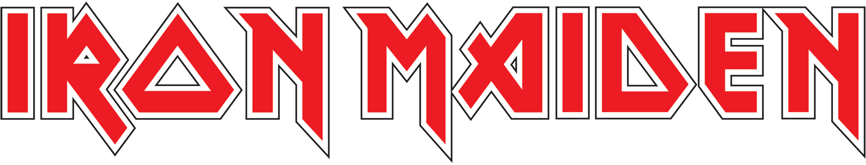

BIOGRAPHY - 2013

As 2013 draws to a close, so does another record-breaking year for IRON MAIDEN. Their

MAIDEN ENGLAND WORLD TOUR continued into Europe and Latin America, with short trip back to the USA for 7 shows, including headlining The Battle Of San Bernadino in LA to 30,000 fans, as the band made their way down to Brazil for Rock In Rio which sold out 90,000 tickets within hours for Maiden’s headline show there on the final night of the Festival. The 2013 dates ended in Chile at the Estadio Nacional, Santiago playing to 60,105 fans: “the largest audience by a British band ever” as reported by national newspaper La Tercera. This year also saw a return to UK’s Donington Park on the 25th Anniversary of the band’s first headline performance at the legendary home of rock in [1988](http://www.ironmaiden.com/poster.html) during the Seventh Son World Tour. This was a record FIFTH time that the band topped the bill at Donington, following two Monsters of Rock performances (1988 and 1992) and two spectacular Download Festivals (2003 and 2007). The MAIDEN ENGLAND World Tour is the next chapter in the History Of Iron Maiden and closely follows 1988’s Seventh Son Of A Seventh Son Tour not only in choice of set list but also in production and content. The original Maiden England ’88 live show was also reissued this year for the very first time on DVD. After 46 shows in 25 countries playing to over a million fans this year alone, the band show no signs of slowing down or losing the formidable passion that has seen them triumphant at the forefront of Metal for three decades.

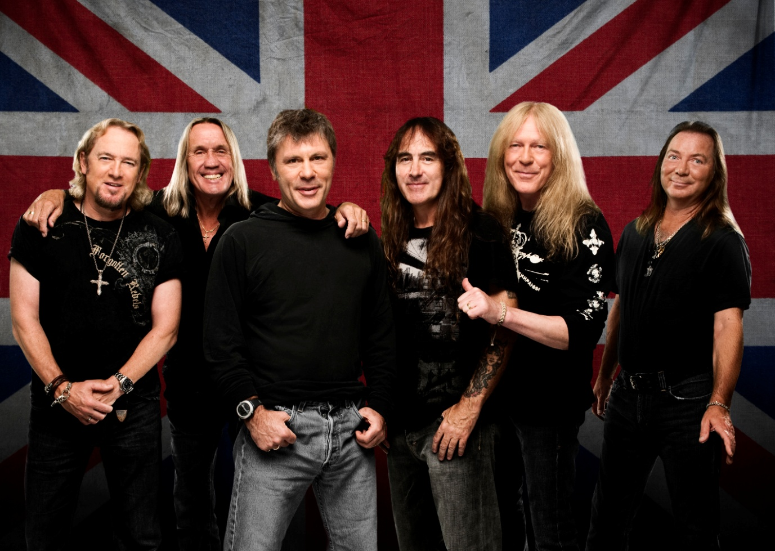  
**Adrian Smith** – Guitar | **Nicko McBrain** – Drums | **Bruce Dickinson** – Vocals  
**Steve Harris** – Bass | **Janick Gers** – Guitar | **Dave Murray** - Guitar

Founded by bassist Steve Harris in the mid ‘70s, Iron Maiden were already firmly established as heavy metal’s brightest hopes when they stormed the world with their third album (and first with vocalist Bruce Dickinson) The Number Of The Beast in 1982. Throughout the decade that followed, Maiden recorded and toured relentlessly with seven new studio albums, one live album: the seminal Live after Death, and seven World Tours in the ‘80s alone. Cementing their reputation as the hardest-touring band on the planet and with the unmistakable figure of band mascot Eddie adorning every album cover and T-shirt, Iron Maiden created a world of their own; one that welcomed fans from every culture, creed and social sphere with a guarantee of heartfelt conviction and unprecedented professionalism.

With milestones like the marathon World Slavery Tour of 1984/5, Rock in Rio in both 1985 and 2001 and headlining Castle Donington’s Monsters Of Rock festival in 1988, (still the biggest ever event there with 107,000 attending), Maiden set new standards, while continually reinventing themselves both musically and visually.

Despite radio play around the world being limited to occasional heavy metal speciality shows and the band’s refusal to deal with celebrity and lifestyle-based mainstream media and magazines, of which there are now so many, the band took metal to many new frontiers; to Poland and behind the Iron Curtain in 1985 at the height of the Cold War,  around South America initially in 1992 and many times since, to the Middle East in 2007, India in the same year,  Indonesia in 2011 and many other new places all around the planet that rarely get visited by major bands.

The ‘90s proved to be a difficult time for heavy metal bands in general, but Iron Maiden ploughed doggedly forward, notching up yet more success with albums like 1992’s acclaimed Fear Of The Dark and even weathering the departure of Bruce Dickinson in 1993. The band made two strong albums with new singer Blaze Bayley and continued to honour their commitment to intensive touring, delivering the goods at every show. However, it was the return of Dickinson and guitarist Adrian Smith (who originally left the band in 1990) in 1999 when  Iron Maiden became a six-piece, that established the ultimate Iron Maiden line-up of Bruce Dickinson on vocals, Steve Harris on bass, Nicko McBrain on drums and “the three amigos” – Adrian Smith, Dave Murray and Janick Gers - on guitar. This line-up has scaled new heights and become increasingly fearless and boldly creative since the release of the Brave New World album in 2000.

With both 2003’s diverse and ingenious Dance Of Death album and its dark and daring follow-up, 2006’s A Matter Of Life And Death, they dazzled fans and critics alike. With each successive tour, whether revisiting classic songs from their first few albums or playing A Matter Of Life And Death in its entirety, Maiden accrued countless new young admirers, momentum building all the while.

This brave new Maiden era reached an astonishing zenith during the band’s Somewhere Back In Time Tour that began in February 2008 and initially took the band 50,000 miles around the world in 45 days, flying in their own specially chartered Boeing 757, Ed Force One, piloted by Bruce Dickinson, a qualified airline captain, traversing the planet, from India to Costa Rica, Australia to Argentina, Sao Paulo to Tokyo. Ed Force One made TV news headlines around the world and the coverage of that tour was subsequently turned into an award-winning film and DVD Flight 666.  Released in 2009 Flight 666 hit the No.1 slot in the music DVD charts in 25 countries, the same year the band picked up their first ever Brit Award for Best British Live Act. Maiden guitarist Dave Murray summed it up nicely when he remarked “Ed Force One certainly beats the battered old van that we, our one crew member and all our equipment used to travel round to gigs in when we first started out!”

The overwhelming success of the Somewhere Back In Time Tour continued into 2009 with sell-out shows across Europe and North America, and a second 50,000+ miles jaunt around the world convinced the band that Ed Force One was the best possible way to reach more fans globally, more quickly and in more territories then they could ever hope to visit by traditional touring methods.

2011 proved another landmark year in the career of IRON MAIDEN following on from the huge success of their 15th studio album The Final Frontier released in 2010. The album became their biggest chart success to date, hitting the number one spot in more than 28 countries round the world, and debuting at an all time high of #4 on Billboard in the U.S.  In February the band resumed The Final Frontier World Tour which had begun in June 2010, once more aboard Ed Force One, and pushing their own boundaries even further on that particular Round The World odyssey which covered 5 continents in 66 days and saw the band fly for the first time ever into such places as Singapore, Indonesia and South Korea for shows there. By the end of The Final Frontier Tour the band had played 98 live shows to over two million fans in 36 countries finishing up with two triumphant concerts at London’s 02 Arena. This same year Maiden released the widely lauded From Fear To Eternity compilation album and the band were also awarded their first ever U.S. Grammy:  Best Metal Performance, for the song El Dorado taken from The Final Frontier album.

The band continued on this high note into 2012 with the release of a live DVD taken from The Final Frontier World Tour. En Vivo! was filmed in front of 50,000 fans in Chile’s National Stadium and hit the #1 spot in the UK and Internationally, becoming Maiden’s fifth consecutive chart-topping live concert DVD. October 2012 saw the start of a series of limited edition releases comprising the first eight albums of Maiden’s career, all originally released in the 1980’s and reissued now as heavyweight gatefold vinyl picture discs.  Among these reissues was the ground-breaking 1982 album The Number Of The Beast which earlier in 2012 was voted Best British Album of the past 60 years in a national public survey conducted by UK retailer HMV to mark the Diamond Jubilee of Queen Elizabeth II. 2012 also saw the start of the Maiden England World Tour, opening with 34 shows in the USA and Canada, the most extensive tour in North America for many years and their most successful to date.

34 years on, and with over 85 million album sales, more than 2000 live performances in 59* countries, tens of millions of satisfied customers and 15 studio albums of unerring quality and power to their name, Iron Maiden have more than earned their proudly-held status as one of the most influential and revered bands ever.

***\*countries  Iron Maiden have played:***

*Chile, Argentina, Uraguay, Peru, Ecuador, Brazil, Colombia, Venezuela, Costa Rica, USA, Canada, Mexico, South Africa, Dubai, Turkey, England, Wales, Scotland, Republic of Ireland, Norway, Sweden, Denmark, Finland, Iceland, Spain, Portugal, France, Italy, Switzerland, Holland, Belgium, Germany, Austria, Poland, Estonia, Hungary, Greece, Northern Ireland, Romania, Czech Republic, Slovakia, Slovenia, Russia, India, Singapore, South Korea, Japan, Indonesia, Australia, New Zealand,  Luxembourg, Malta, Israel, Bulgaria, Croatia, Ukraine, Serbia, Macedonia, Paraguay.*